Practical No :-04

Write a program to imlpement FCFS algorithm

Input:-

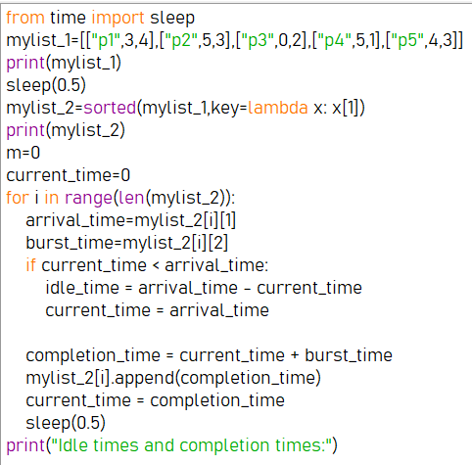

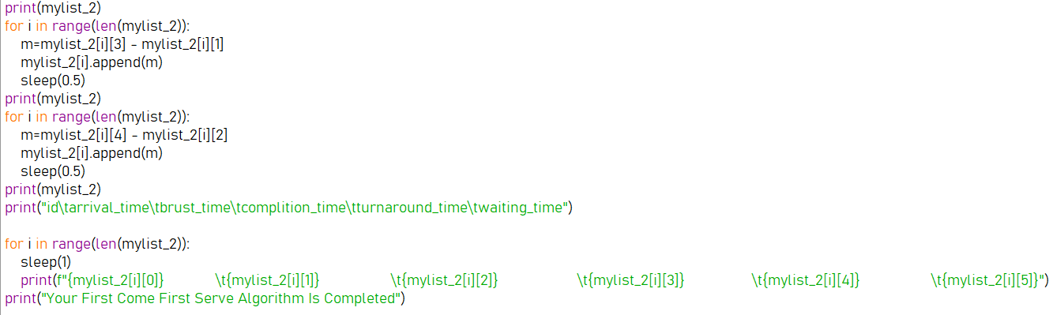

Output:-

